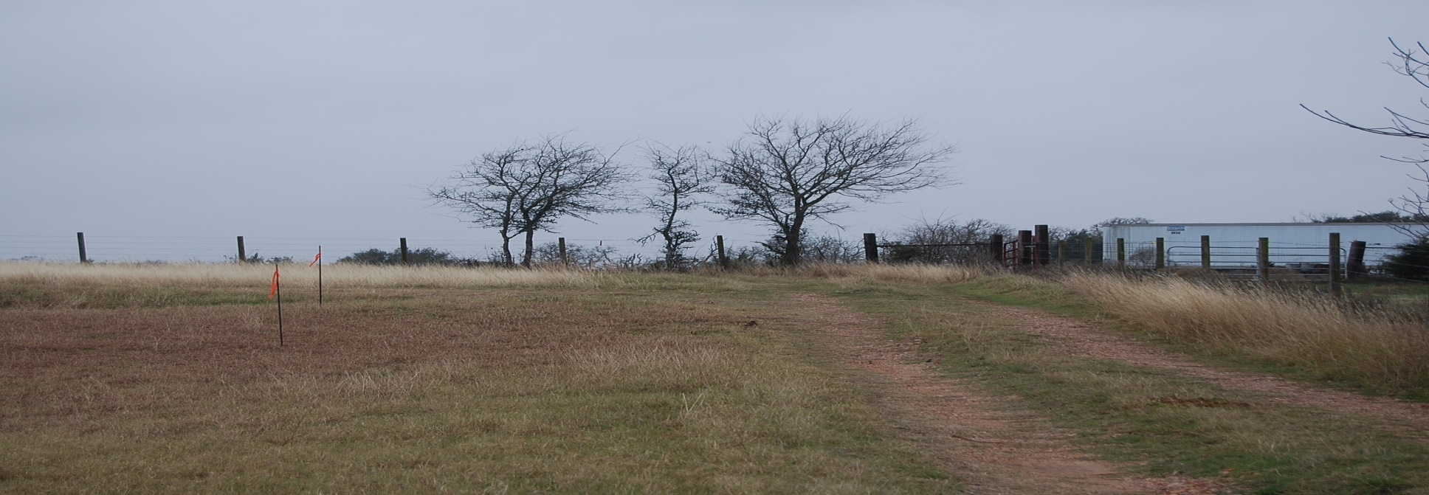  The Blue Rock Banner |  | July 2026  Issue 12
Jaeger-Witte Heritage Cemetery Association

Jaeger Witte Heritage  Cemetery Association  3802 Costa Rica Rd  Houston TX 77092  www.JWHCA.org  INSIDE THIS ISSUE  - Annual Report  - How to Get Involved  - Project Updates  - Announcements  CURRENT OFFICERS  President  Jeff Featherston  Vice-President  Steven Jaeger  Secretary  George Zemanek  Treasurer  Debbie Byrd  Grounds and Maintenance  Kay Kulow | Annual Report  This has been an eventful and productive year for the Jaeger Witte Heritage Cemetery Association. After several years of planning, research, and preparation, we successfully completed construction of a beautiful blue storage shed in a shaded area along the side of the cemetery. The project required many hours of work over several days, but the finished result has made the effort worthwhile. We have also begun the ongoing task of repainting the cemetery fence, a project that requires patience and flexibility as progress is often dependent on weather conditions.  We are also excited to announce that, in addition to our printed newsletter, we now offer a digital newsletter option. By scanning the QR code below, family members and friends can register to receive updates electronically. This new option has already helped us expand our reach and connect with other family cemetery associations, strengthening relationships and creating new opportunities to share ideas and preserve our heritage.  Family Directory  Do you need a copy of the Jaeger family directory? Please contact George for a print or digital copy. 281-827-5350 g.zemanek.1@gmail.com  Newsletter  
The Blue Rock Banner

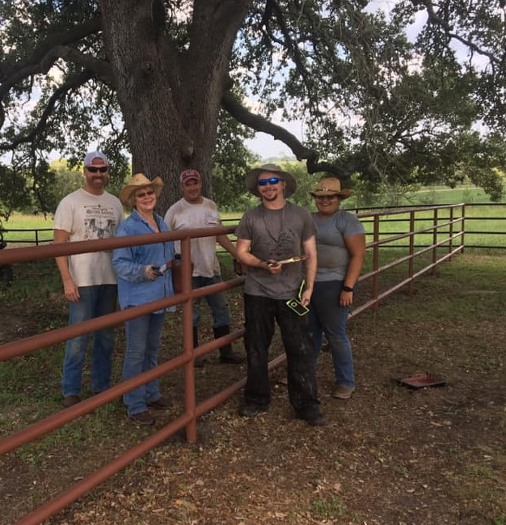

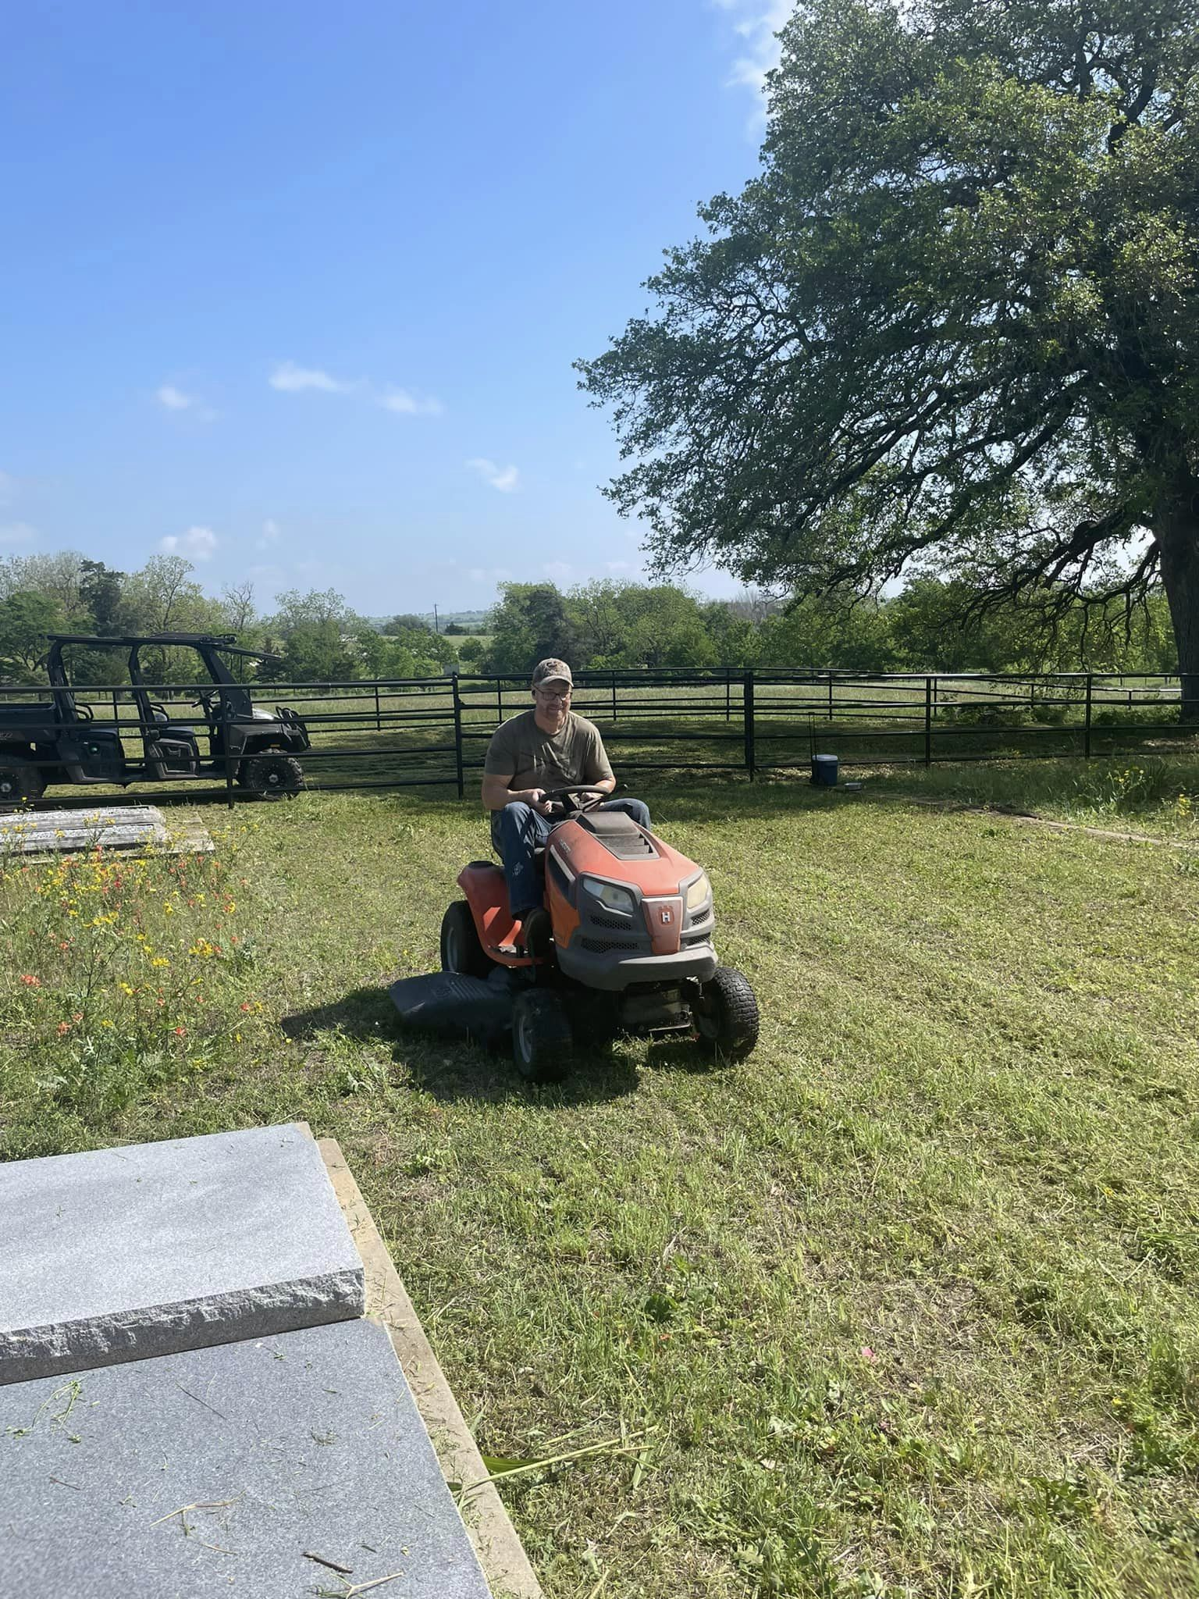

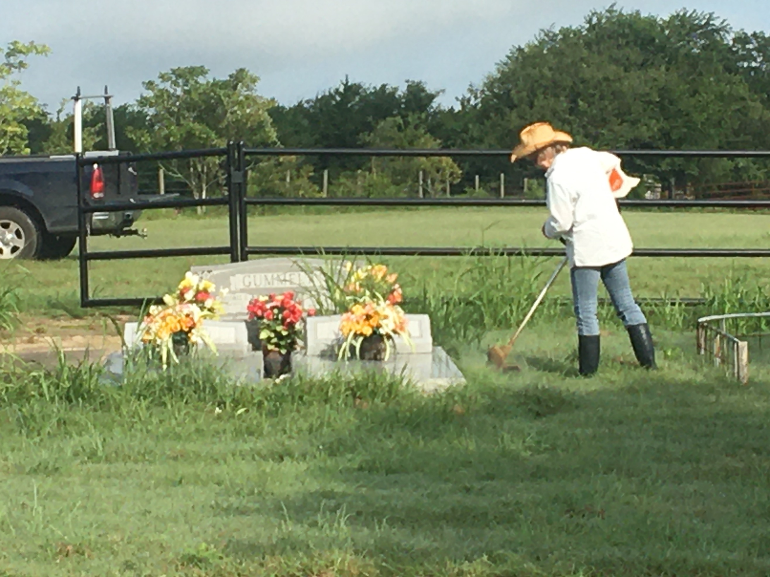

How to Get Involved

The family meets throughout the year for routine maintenance. We generally begin at 8:00 am and finish by noon. Please contact Kay Kulow at kaylynnkulow.kay@gmail.com or 979-277-8807 for more information.

The Jaeger Witte Heritage Cemetery Association is supported through generous donations from friends and family. Your tax-deductible contributions are used to offset the cost of perpetual care and special projects. We accept checks, Venmo, Cashapp, and have a Go Fund Me page.



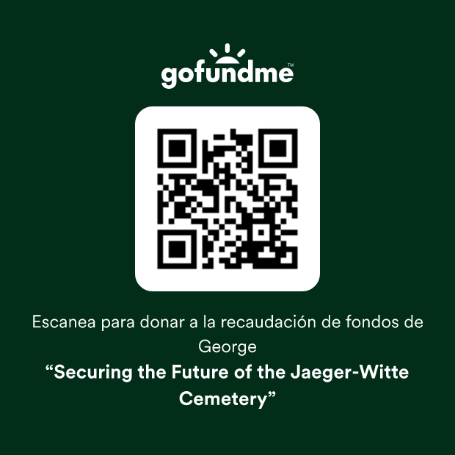

Page 2

Page 3
The Blue Rock Banner
Project Updates

Mel Jaeger, son of Henry and Lillie Jaeger, built a wooden shed for the family cemetery several decades ago. The shed's door was decorated with three crosses and had hooks and a table for tools and equipment. For nearly thirty years, this humble shed housed our mower, painting supplies, concrete, and anything else we needed during our cleanup days. We also used the shed to store metal flower stands during a mournful period lasting 2007-2012, when my generation lost seven aunts and uncles.

The shed began falling down a couple of years ago and was kept propped up only by a few bricks and a wooden post. Mice and yellow jackets set up their nests, and the space became a hazard. A windstorm finally knocked the door off, and we realized the time had come to replace it. On October 4th, cousins Debbie, George, Jeff, Steven, Kay, Cameron, Caydon, and Mike came together to pour the concrete foundation and on October 15th, the new shed was erected. This and other projects are made possible through generous donations from family, friends, and supporters. Thanks everyone!

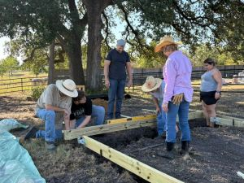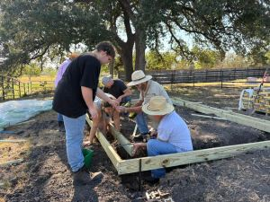
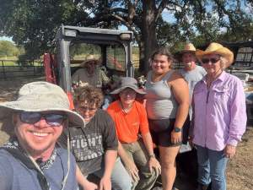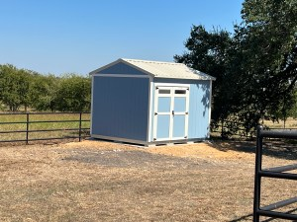

Page 4

Announcements!

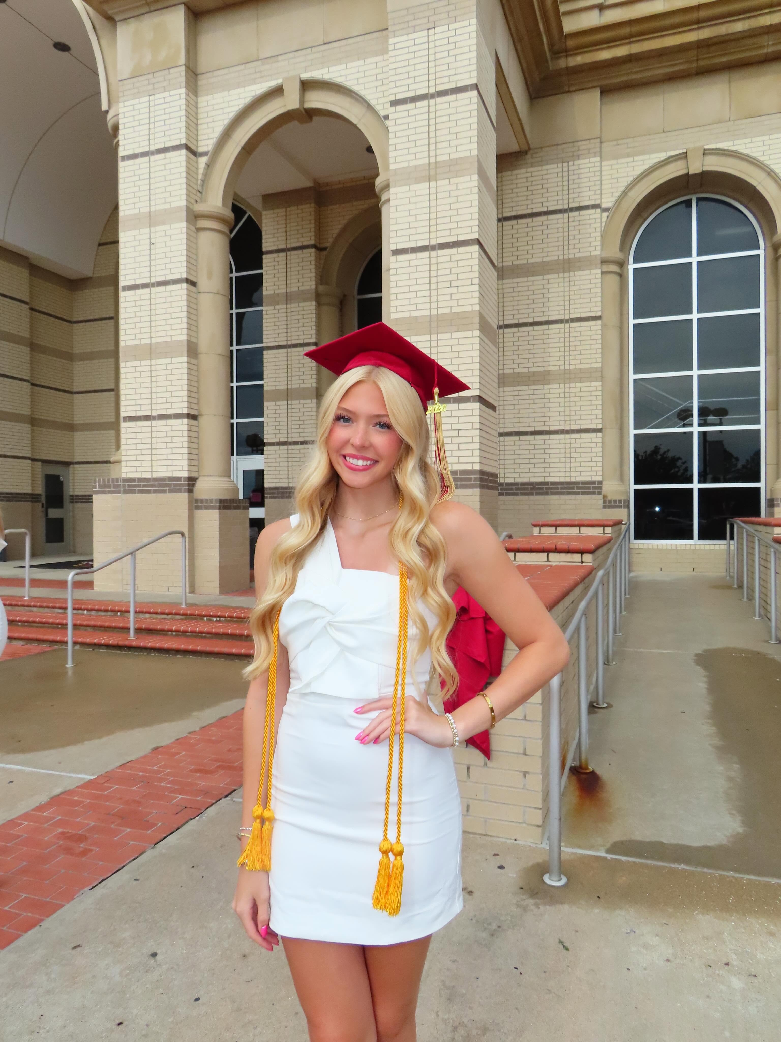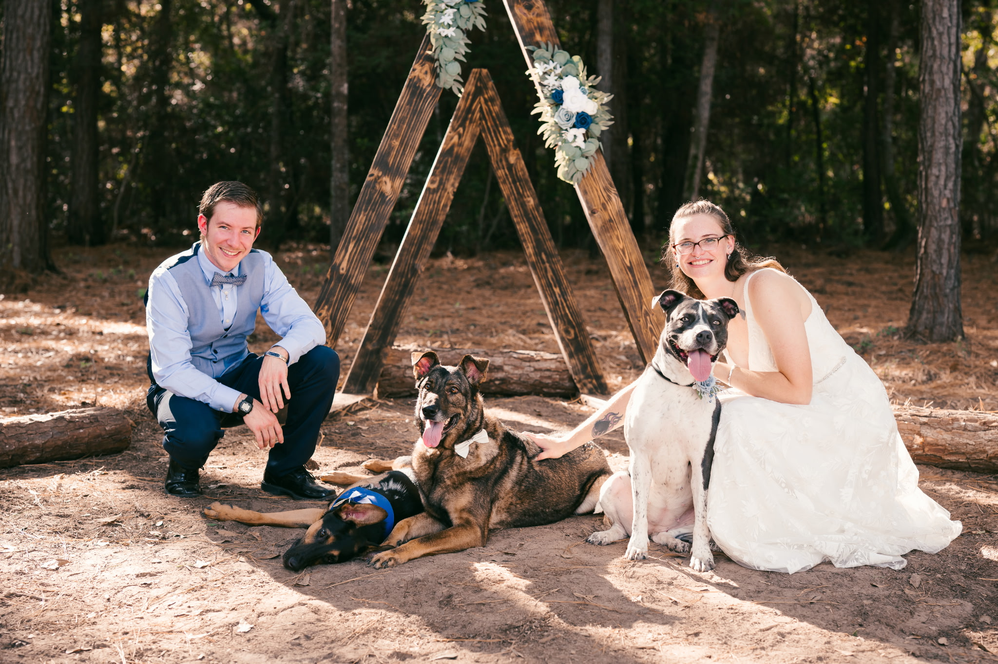

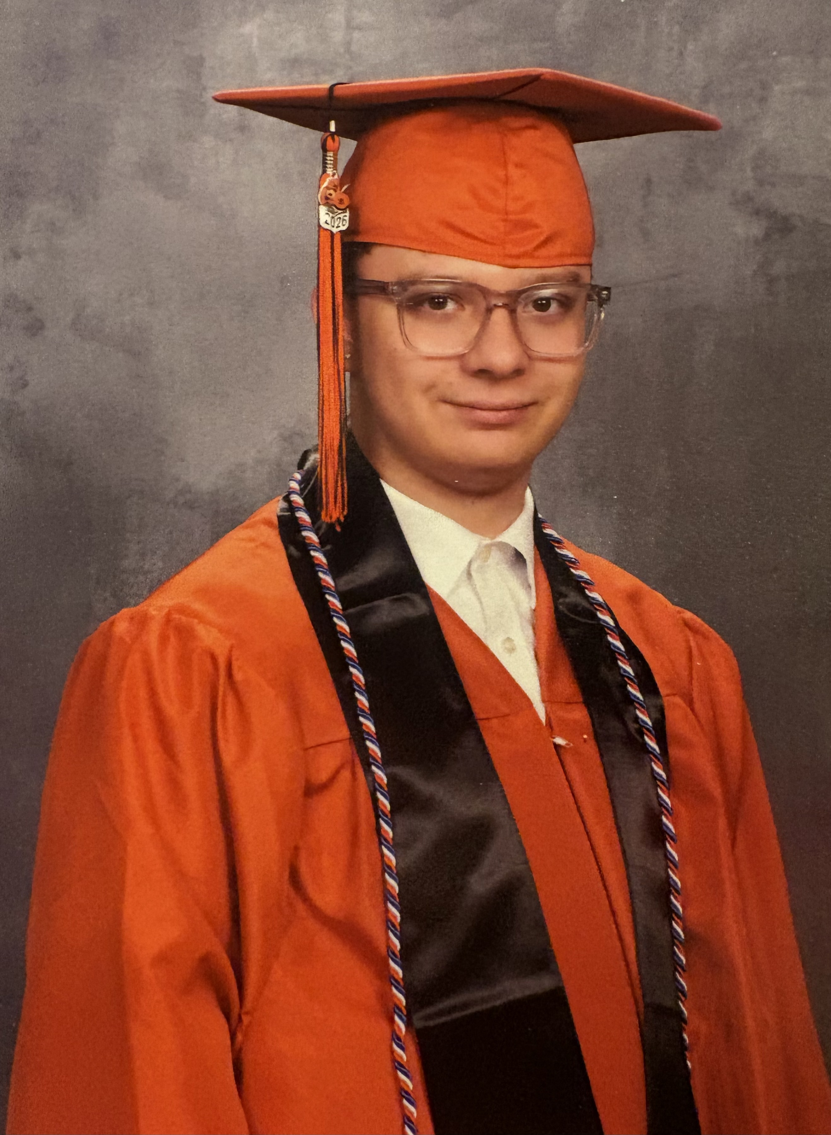

Sarah (daughter of Keith and Michele Goar) and Ashton Goar got married on October 18, 2025. They’re pictured here with Richter, Ripley, and Rin.
Caydon Heckert (son of George Zemanek and John Merullo)
graduated from Scarborough High School and is headed to
Houston City College EMT program.



Chris (son of Chris and Kellie Kulow) and Rebecca Kulow welcomed their daughter Lillie, on November 25th.

Cameron Kulow graduated from Brenham High School!
Savanna Featherston (daughter of Jeff and Licia Featherston) graduated from Cy Woods High School and is headed to Blinn in the fall!

The Blue Rock
Banner

